**Reference for Common Functionality of RMarkdown**

*27 January 2021*

**Links:**

Links to RMarkdown resources that could be useful and this document could be based on the content in some of these links.

* <https://rmarkdown.rstudio.com/lesson-1.html>
* <https://rstudio.github.io/visual-markdown-editing/#/markdown>
* <https://www.rstudio.com/wp-content/uploads/2016/03/rmarkdown-cheatsheet-2.0.pdf?_ga=2.114546062.867792584.1611653172-787395666.1608309879>
* <https://rstudio.com/wp-content/uploads/2015/03/rmarkdown-reference.pdf?_ga=2.114546062.867792584.1611653172-787395666.1608309879>

**Installation**

install.packages("rmarkdown")

**How It Works**

* Plain text file with .Rmd extension
* 3 types of content:

1. Optional YAML header [---s used]
2. R code chunks [```s used]
3. Text with simple text formatting

* Notebook interface in RStudio
* Rendering Output: use render command or Knit button in RStudio

e.g.:

library(rmarkdown)

render("1-example.Rmd")

* RMarkdown generates a new file with text, code, results from Rmd file. Multiple different possible output format

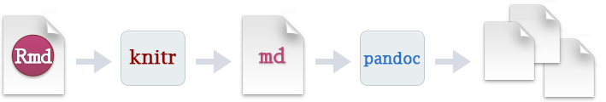

**Code Chunks**

dfzd